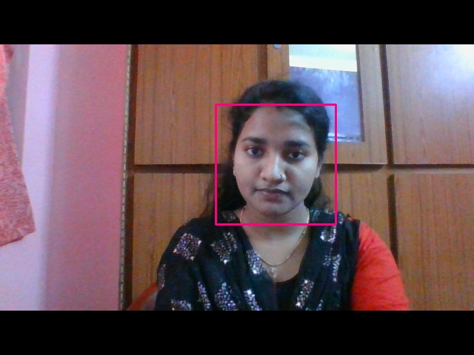

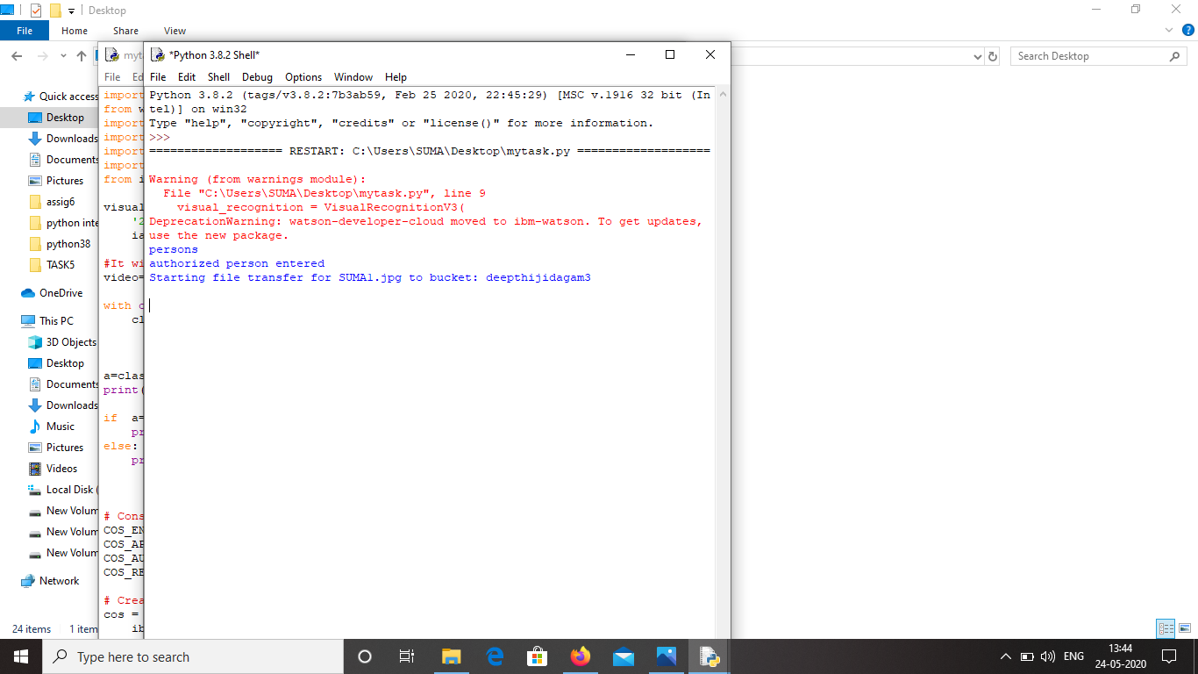

<https://s3.jp-tok.cloud-object-storage.appdomain.cloud/deepthijidagam3/SUMA1.jpg>